A. Assignment Information
Particular | Details
Department | Department of Computer Science and Engineering
Programme | B.Tech –AI&DS
Course Code & Course Name | CSA0702 – Computer Networks
Academic Year / Batch | 2024–2028
Faculty Name | Dr. SENTHAMILSELVAN R
Assignment Title | Design and Implementation of a VLAN-Based Enterprise  LAN
Date of Issue | 31-08-2026
Date of Submission | 01-09-2026
Maximum Marks | 100
Course Outcome(s) – CO | CO1, CO2, CO3, CO4, CO5
Bloom’s Taxonomy Level | L6 – Design; L5 – Evaluate; L4 – Analyze; L3 –  Configure; L2 – Explain
SDG Mapping | SDG 4 – Quality Education; SDG 9 – Industry,  Innovation and Infrastructure; SDG 11 – Sustainable  Cities and Communities
Industry / Societal Relevance | VLAN-based network segmentation is widely used in enterprises, educational institutions, and other organizations to improve network organization, security, traffic management, scalability, and reliability.

Course Outcome(s) – CO
CO1: Identify and explain fundamental networking concepts, network devices, topologies, protocols, and layered network architectures.
CO2: Configure IP addressing, subnetting, switching, and routing techniques for establishing computer networks using Cisco Packet Tracer.
CO3: Analyse network traffic, addressing information, VLAN communication, and connectivity using appropriate network simulation and packet-analysis tools.
CO4: Evaluate network performance, connectivity, segmentation, and security requirements for different enterprise networking scenarios.
CO5: Design and implement VLAN-based enterprise networks by creating separate VLANs for Administration, Faculty, Students, and Guests, configuring inter-VLAN communication, and verifying connectivity using Cisco Packet Tracer.
Bloom's Taxonomy Level
L6 – Design; L5 – Evaluate; L4 – Analyse; L3 – Configure; L2 – Explain.

SDG Mapping
- SDG 4 – Quality Education: Develops practical networking knowledge, digital skills, analytical abilities, and hands-on technical competency.
- SDG 9 – Industry, Innovation and Infrastructure: Promotes the design and implementation of reliable, secure, scalable, and innovative ICT infrastructure.
- SDG 11 – Sustainable Cities and Communities: Provides networking skills relevant to connected campuses, smart buildings, smart cities, and resilient digital services.

Industry / Societal Relevance
Modern organizations require secure and well-organized networks to support multiple departments and users. VLAN technology provides logical network segmentation, reduces unnecessary broadcast traffic, improves security, and simplifies network management. The proposed VLAN-based enterprise LAN is relevant to offices, educational institutions, industries, and smart infrastructure environments.

B. ASSIGNMENT PROBLEM / CHALLENGE
Design and implement a VLAN-based enterprise Local Area Network using Cisco Packet Tracer. The organization contains four departments:
- Administration
- Faculty
- Students
- Guests
Each department must be logically separated using a dedicated VLAN. Appropriate IP addressing, switch-port assignments, VLAN configuration, inter-VLAN communication, and connectivity testing must be implemented. The design should provide proper communication between authorized network segments while maintaining effective departmental segmentation.

C. PROBLEM STATEMENT
The objective of this assignment is to design and implement a VLAN-based enterprise LAN for an organization with four different user groups: Administration, Faculty, Students, and Guests. A traditional flat network places all devices in a single broadcast domain. This can result in excessive broadcast traffic, poor security, difficult network management, and unrestricted communication between unrelated departments. The proposed solution divides the enterprise network into four separate VLANs. Each VLAN represents a separate logical network. A Layer 3 device is used to provide controlled inter-VLAN communication.
The final network must:
- Create four VLANs.
- Assign switch ports to appropriate VLANs.
- Configure IP addresses for all devices.
- Configure trunk communication.
- Configure inter-VLAN routing.
- Verify connectivity using ping and switch/router commands.
- Analyze and troubleshoot possible configuration errors.

D. REQUIREMENTS AND CONSTRAINTS
1. Functional Requirements The network shall:
- Support Administration, Faculty, Students, and Guests.
- Create separate VLANs for each department.
- Assign end devices to the correct VLAN.
- Provide IP addressing for each VLAN.
- Enable inter-VLAN routing.
- Verify successful communication.
- Maintain logical separation between departments.

2. Technical Requirements
- Cisco Packet Tracer must be used.
- A Cisco switch and router must be configured.
- IEEE 802.1Q trunking must be used between the switch and router.
- Unique IP subnets must be assigned to every VLAN.
- Router-on-a-Stick inter-VLAN routing must be implemented.

3. Constraints
- The network is implemented in a simulation environment.
- Available switch ports must be efficiently allocated.
- Each VLAN must use a different IP subnet.
- Incorrect trunking or VLAN assignment may cause communication failure.
- Guest network access should be logically isolated and controlled.

E. WORK
1. Problem Understanding and Formulation What is the problem?
The problem is to design an enterprise network containing four different departments while preventing all devices from operating in one large broadcast domain.

Expected Outcomes
The expected outcomes are:
- Successful creation of four VLANs.
- Proper port-to-VLAN assignment.
- Correct IP addressing.
- Successful inter-VLAN routing.
- Successful connectivity testing.
- Identification and correction of configuration errors.

Available Information
The available information includes the four required departments and the requirement to use VLANs, IP addressing, inter-VLAN communication, and Cisco Packet Tracer.

Assumptions
The following assumptions are made:
- One switch is sufficient for the initial network design.
- One router is used for inter-VLAN routing.
- Each department has two PCs for testing.
- The router is connected to the switch using a trunk link.
- IPv4 addressing is used.

Constraints to be Satisfied
- Separate VLANs must be maintained.
- Every VLAN requires a unique subnet.
- Switch ports must be correctly assigned.
- The router must contain a sub interface for each VLAN.
- The trunk link must carry all required VLANs.
2. APPLICATION OF COURSE KNOWLEDGE
The following Computer Networks concepts are applied.

VLAN
A Virtual Local Area Network logically divides a physical network into multiple broadcast domains. Devices belonging to the same VLAN can communicate at Layer 2 even when separated from devices in other VLANs.

VLAN IDs
The following VLAN numbering scheme is used:
Department | VLAN ID | VLAN Name
Administration | 10 | ADMIN
Faculty | 20 | FACULTY
Students | 30 | STUDENTS
Guests | 40 | GUESTS

IP Addressing and Subnetting
Each VLAN receives a separate IPv4 subnet.
VLAN | Network Address | Default Gateway | Subnet Mask
VLAN 10 | 192.168.10.0/24 | 192.168.10.1 | 255.255.255.0
VLAN 20 | 192.168.20.0/24 | 192.168.20.1 | 255.255.255.0
VLAN 30 | 192.168.30.0/24 | 192.168.30.1 | 255.255.255.0
VLAN 40 | 192.168.40.0/24 | 192.168.40.1 | 255.255.255.0

Using separate subnets ensures that each VLAN represents a different logical IP network.
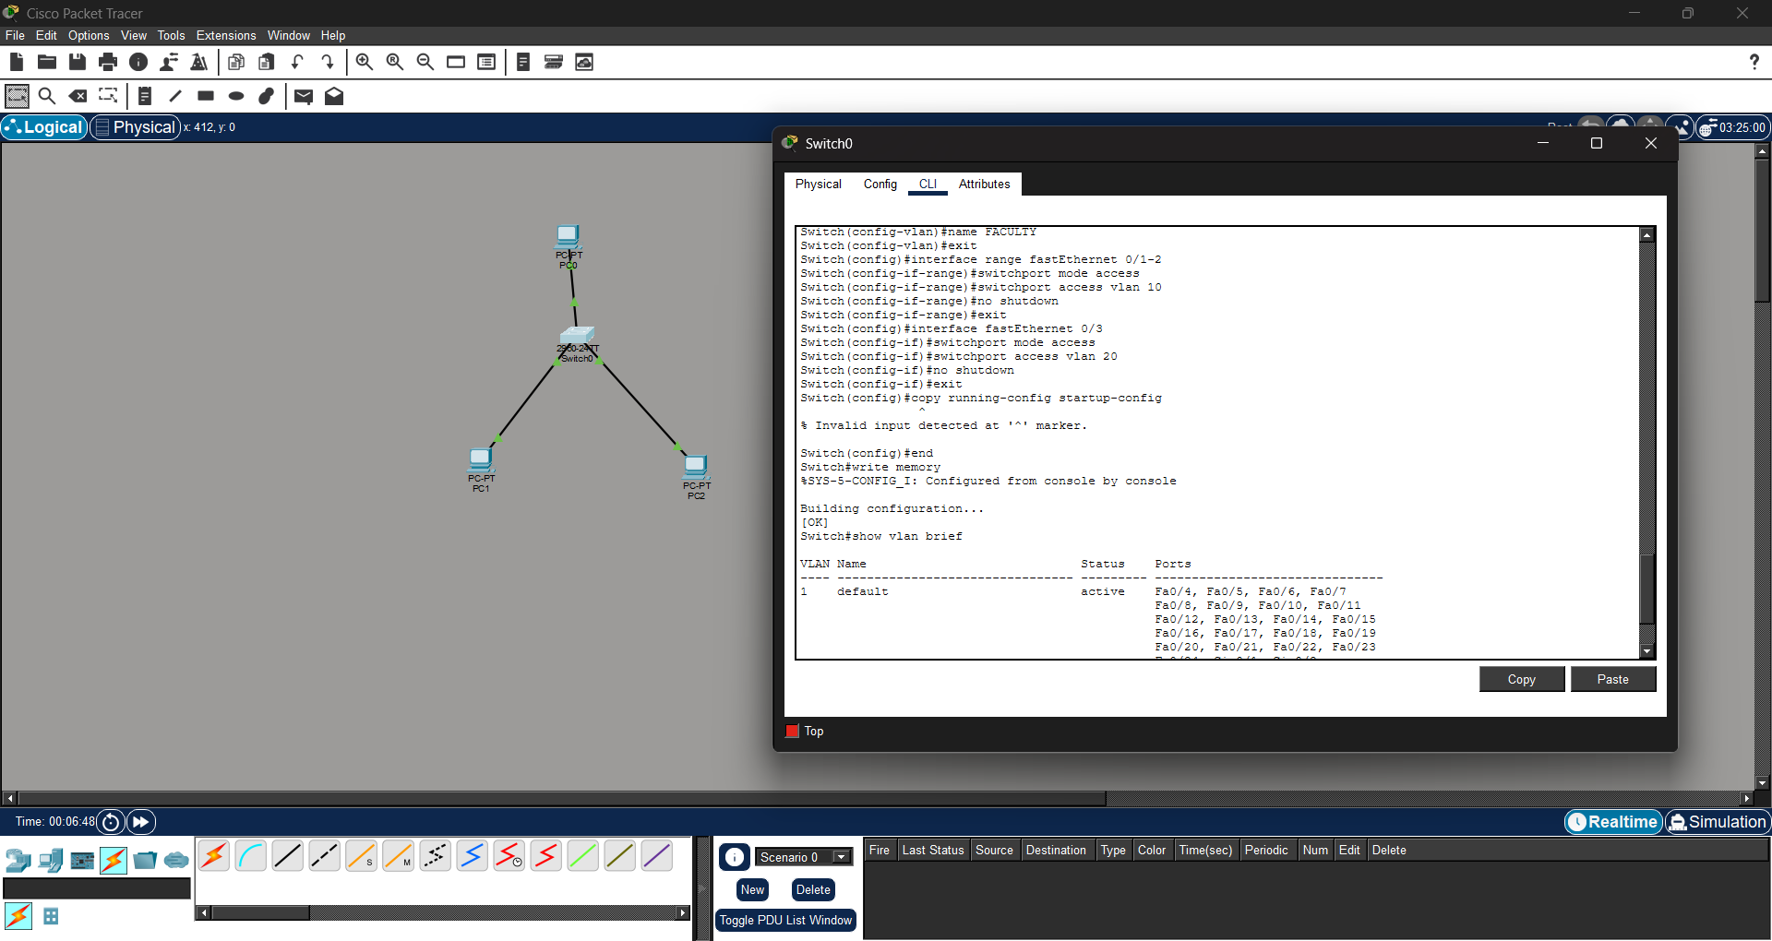

Fig:1- Troubleshooting/verification commands.

Inter-VLAN Routing
Devices in different VLANs cannot communicate directly through Layer 2 switching. A Layer 3 device is required. In this design, Router-on-a-Stick is used. The router interface is divided into multiple sub interfaces, with one sub interface assigned to each VLAN.
3. SOLUTION / DESIGN / METHODOLOGY

Proposed Network Topology
The proposed topology consists of:
- 1 Router
- 1 Cisco Switch
- 8 PCs
- 4 VLANs
Device Allocation
Device Group | Number of PCs | VLAN
Administration | 2 | VLAN 10
Faculty | 2 | VLAN 20
Students | 2 | VLAN 30
Guests | 2 | VLAN 40

Suggested Port Allocation
Switch Ports | Department | VLAN
Fa0/1 – Fa0/2 | Administration | 10
Fa0/3 – Fa0/4 | Faculty | 20
Fa0/5 – Fa0/6 | Students | 30
Fa0/7 – Fa0/8 | Guests | 40
Fa0/24 | Router Trunk | All VLANs

Logical Topology

VLAN Configuration
The following VLANs are created on the switch:
enable configure terminal vlan 10
name ADMIN
vlan 20
name FACULTY
vlan 30
name STUDENTS
vlan 40
name GUESTS
end
Switch Port Assignment enable configure terminal interface range fa0/1-2 switchport mode access switchport access vlan 10 interface range fa0/3-4 switchport mode access switchport access vlan 20 interface range fa0/5-6 switchport mode access switchport access vlan 30 interface range fa0/7-8 switchport mode access switchport access vlan 40 end

Router-on-a-Stick Configuration
Assume the router is connected through interface GigabitEthernet0/0.
enable
configure terminal interface gigabitEthernet0/0 no shutdown

VLAN 10
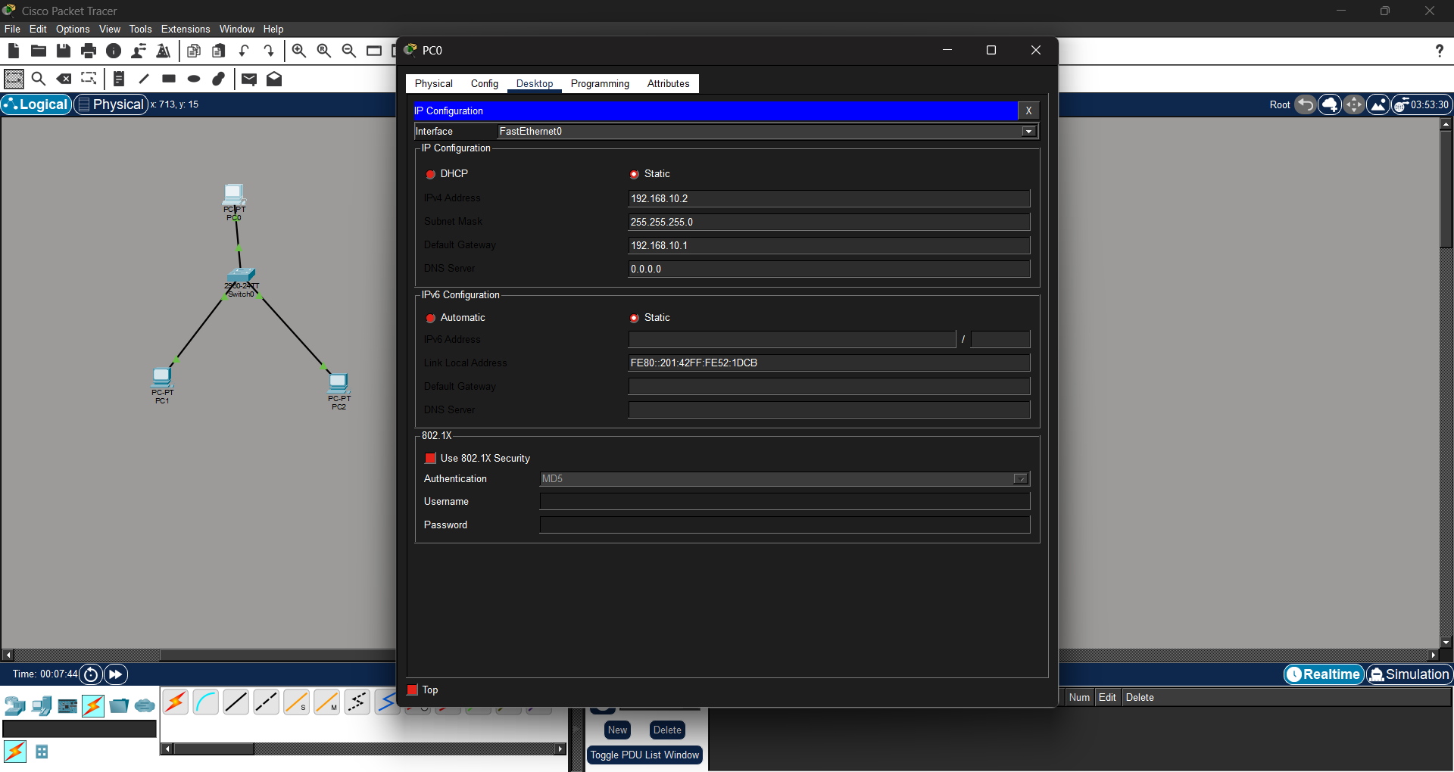

Fig: 2- IP configuration of PCs
interface gigabitEthernet0/0.10 encapsulation dot1Q 10
ip address 192.168.10.1 255.255.255.0 VLAN 20

interface gigabitEthernet0/0.20

encapsulation dot1Q 20 ip address 192.168.20.1 255.255.255.0 VLAN 30 interface gigabitEthernet0/0.30 encapsulation dot1Q 30 ip address
192.168.30.1 255.255.255.0 VLAN 40
interface gigabitEthernet0/0.40
encapsulation dot1Q 40 ip address 192.168.40.1 255.255.255.0 end write memory
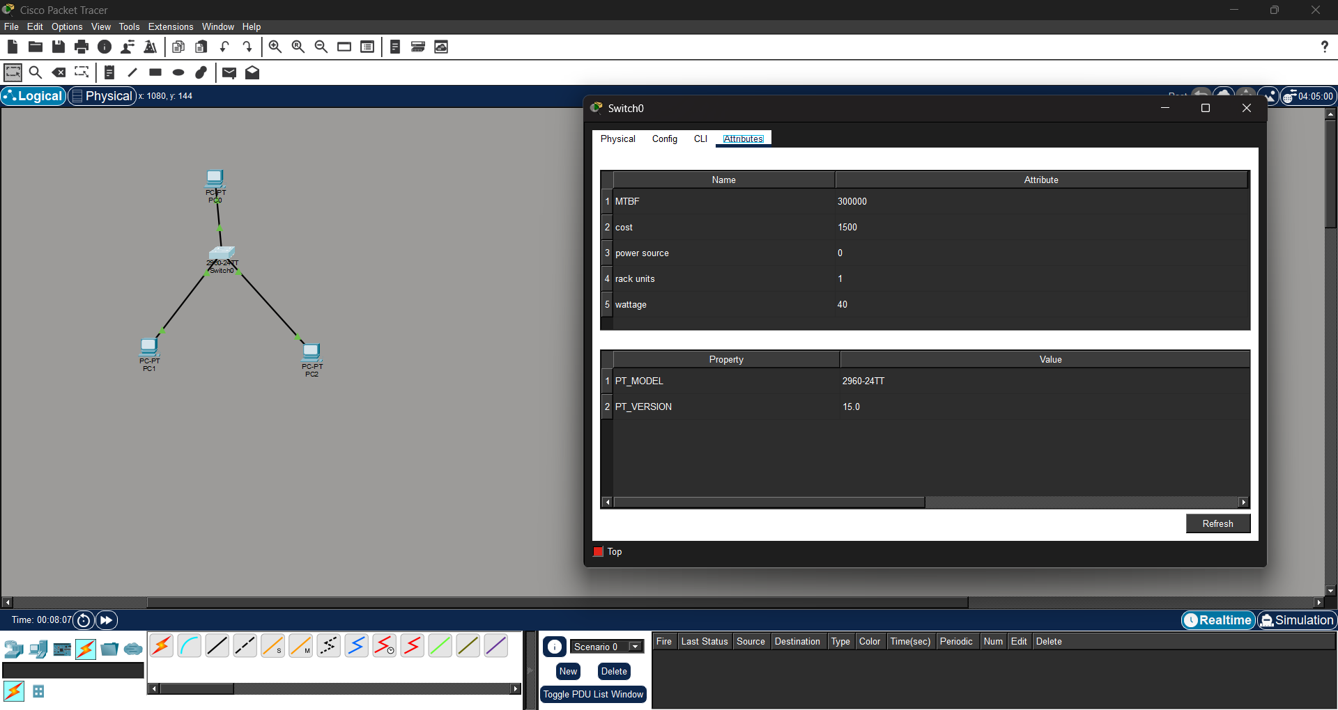
Fig: 3- Switch port assignments

4. USE OF MODERN TOOLS
The assignment is implemented using Cisco Packet Tracer.
Cisco Packet Tracer is used to:
- Design the network topology.
- Add routers, switches, and PCs.
- Create VLANs.
- Configure switch ports.
- Configure router subinterfaces.
- Assign IP addresses.
- Test connectivity.
- Identify configuration errors.
- Simulate packet transmission.
Evidence of tool usage should include screenshots of:
- Complete topology.
- VLAN configuration.
- Switch port assignments.
- Trunk configuration.
- Router subinterface configuration.
- IP configuration of PCs.
- Successful ping results.
The assignment format specifically expects evidence of modern-tool usage and outputs.
5. RESULTS AND VALIDATION

Expected Device IP Addresses
Device | IP Address | Gateway | VLAN
Admin-PC1 | 192.168.10.10 | 192.168.10.1 | 10
Admin-PC2 | 192.168.10.11 | 192.168.10.1 | 10
Faculty-PC1 | 192.168.20.10 | 192.168.20.1 | 20
Faculty-PC2 | 192.168.20.11 | 192.168.20.1 | 20
Student-PC1 | 192.168.30.10 | 192.168.30.1 | 30
Student-PC2 | 192.168.30.11 | 192.168.30.1 | 30
Guest-PC1 | 192.168.40.10 | 192.168.40.1 | 40
Guest-PC2 | 192.168.40.11 | 192.168.40.1 | 40

Validation Commands Verify VLANs
show vlan brief
Expected result: VLANs 10, 20, 30, and 40 should be displayed with their assigned ports.
Verify Trunk show interfaces trunk
Expected result: Router sub interfaces should be configured with the correct IP addresses.

Connectivity Testing
From Admin-PC1: ping
192.168.10.11 ping
192.168.20.10 ping
192.168.30.10 ping
192.168.40.10
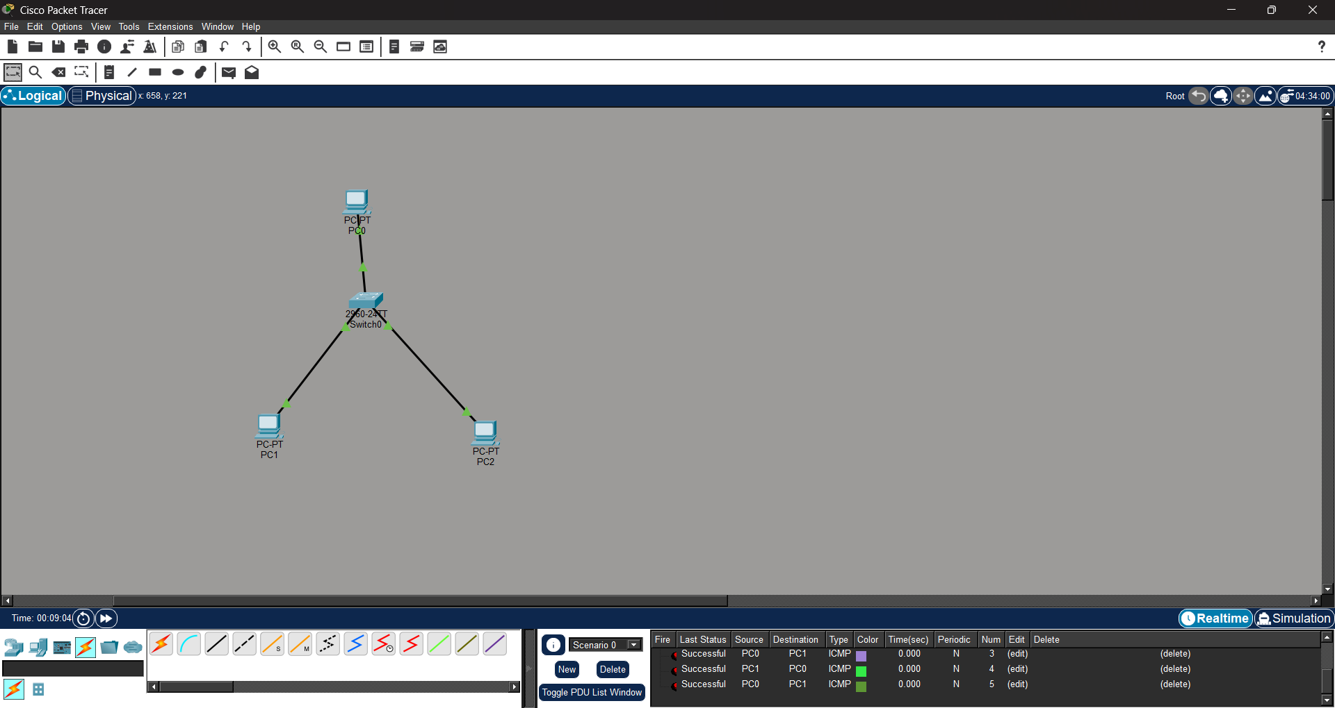
Fig:1- Successful replies confirm that VLAN configuration and inter-VLAN routing are functioning. The required assignment format expects validation through test results, screenshots, simulation outputs, and appropriate evidence that requirements are satisfied.
6. ANALYSIS AND ENGINEERING DECISION

Alternative Approaches
Two approaches were considered for inter-VLAN communication:
Approach 1: Router-on-a-Stick Advantages:
- Requires only one physical router interface.
- Lower hardware requirement.
- Suitable for small and medium enterprise networks.
- Easy to implement in Cisco Packet Tracer.
Limitation:
- All inter-VLAN traffic passes through one physical link. Approach 2: Layer
3 Switch Advantages:
- Faster inter-VLAN routing.
- Better scalability.
- Reduced routing bottleneck.
Limitations:
- Higher cost.
- More advanced configuration.

Final Decision
Router-on-a-Stick was selected because the assignment requires a manageable enterprise LAN simulation with limited devices. It provides an effective balance between simplicity, functionality, and implementation cost.
The VLAN design improves:
- Network organization.
- Broadcast traffic management.
- Departmental segmentation.
- Security.
- Scalability.

TROUBLESHOOTING AND ANALYSIS
Problem 1: PCs Cannot Communicate Within the Same VLAN Possible Cause: Switch port assigned to the wrong VLAN.
Solution:
interface fa0/1 switchport mode access switchport access vlan 10

Problem 2: Different VLANs Cannot Communicate
Possible Cause: Router subinterfaces are missing or incorrectly configured.
Solution: Verify the following:
show ip interface brief
Configure the required subinterfaces with the correct VLAN IDs and IP addresses.

Problem 3: Trunk Link Not Working
Possible Cause: The switch port connected to the router is not configured as a trunk.
Solution:
interface fa0/24
switchport mode trunk Verify using:
show interfaces trunk Problem
4: Ping Fails Possible Causes:
- Incorrect IP address.
- Incorrect subnet mask.
- Incorrect default gateway.
- VLAN mismatch.
- Router interface shutdown.
Solution: Check PC IP configuration and execute:
show vlan brief show interfaces trunk show ip interface brief
Then correct the identified configuration. Troubleshooting is especially important because the assessment rubric allocates significant marks to independently identifying and resolving issues.
7. BROADER CONSIDERATIONS

Security
VLAN segmentation provides logical separation between departments. Sensitive Administration traffic can be separated from Student and Guest traffic.

Scalability
Additional departments can be added by creating new VLANs and allocating new IP subnets.

Cost
The Router-on-a-Stick design reduces hardware requirements because multiple VLANs use one physical router interface.

Sustainability
Efficient network design reduces unnecessary broadcast traffic and supports reliable
digital infrastructure.

Professional Responsibility
Network engineers must configure secure, reliable, and maintainable networks. Proper VLAN design reduces the possibility of unauthorized access and network misconfiguration. The common format specifically calls for consideration of broader impacts such as sustainability, society, safety, ethics, economics, and professional responsibility where relevant.

8. CONCLUSION
A VLAN-based enterprise LAN was successfully designed for Administration, Faculty, Students, and Guests. Four separate VLANs were created to logically divide the network into independent broadcast domains. The network was configured using Cisco Packet Tracer with appropriate VLAN IDs, switch port assignments, IPv4 addressing, trunking, and Router-onaStick inter-VLAN routing. The results demonstrate that VLAN technology improves network organization, reduces unnecessary broadcast traffic, and provides better security through logical segmentation. Connectivity was validated using VLAN verification commands, interface checks, and ping testing. The design satisfies the primary assignment requirements. A future improvement would be to use a Layer 3 switch, access control lists, DHCP, redundant switches, and additional security policies for a larger enterprise network.

9. REFLECTION
This assignment provided practical experience beyond theoretical understanding of VLANs and IP addressing. I learned how a physical network can be logically divided into multiple independent networks using VLAN technology. I gained practical knowledge of creating VLANs, assigning switch ports, configuring trunk links, implementing Router-onaStick inter-VLAN routing, and troubleshooting connectivity problems. I also understood the importance of correct IP addressing and default gateway configuration. If additional time and resources were available, I would improve the network by implementing a Layer 3 switch, Access Control Lists for restricting Guest access, DHCP for automatic IP allocation, redundant network devices, and stronger enterprise security mechanisms. This assignment also demonstrates the relevance of SDG 9, as reliable and scalable network infrastructure is essential for modern organizations, industries, educational institutions, and digital services.

10. REFERENCES
- A. S. Tanenbaum and D. J. Wetherall, Computer Networks, 5th ed. Boston, MA, USA:
Pearson, 2011.
- J. F. Kurose and K. W. Ross, Computer Networking: A Top-Down Approach, 8th ed.
Hoboken, NJ, USA: Pearson, 2021.
- W. Stallings, Data and Computer Communications, 10th ed. Boston, MA, USA: Pearson, 2013.
- Cisco Systems, Inc., Cisco IOS Interface and Hardware Component Command Reference.
San Jose, CA, USA: Cisco Systems, Inc.
- Cisco Systems, Inc., Cisco Packet Tracer. San Jose, CA, USA: Cisco Systems, Inc.
- IEEE, “IEEE Standard for Local and Metropolitan Area Networks—Bridges and Virtual Bridged Local Area Networks,” IEEE Std 802.1Q-2018, IEEE, 2018.
- E. Rosen, A. Viswanathan, and R. Callon, “Multiprotocol Label Switching Architecture,” RFC 3031, Internet Engineering Task Force, Jan. 2001.
- J. Postel, “Internet Protocol,” RFC 791, Internet Engineering Task Force, Sep. 1981.
- Cisco Systems, Inc., “VLAN Configuration Guide,” Cisco Systems, Inc.
- Cisco Systems, Inc., “Inter-VLAN Routing Configuration,” Cisco Systems, Inc.

